Assighnment on making a Website for My School

Course Title: Web and internet programming

Course Code: CSE4033

Section:1

Submitted to:

Md. Mijanur Rahman

Assistant Professor, CSE

Submitted by:

Name: Helena Aktar Reya

ID: 2018100000030

Date of Submission: 04-12-2021

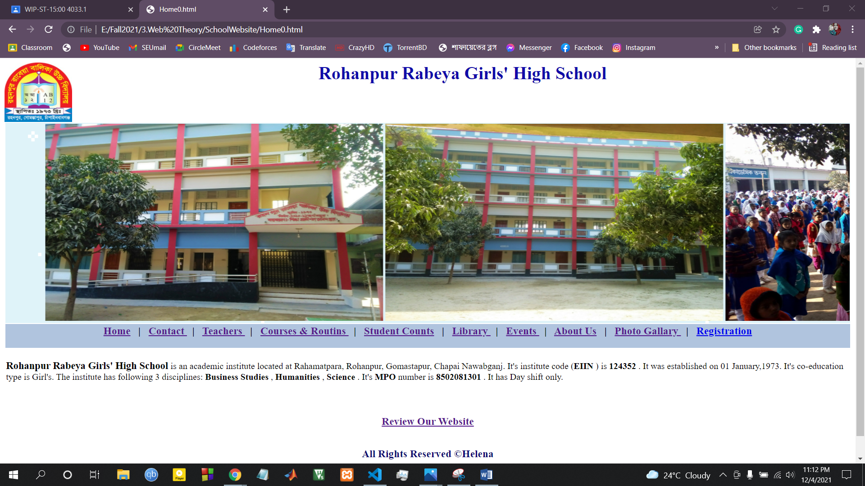

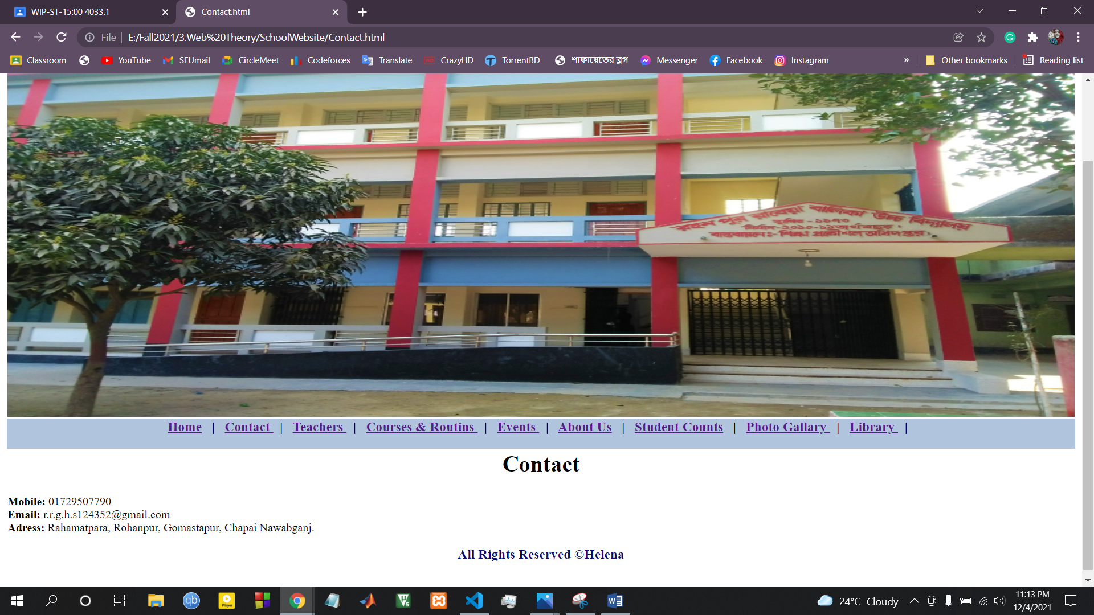

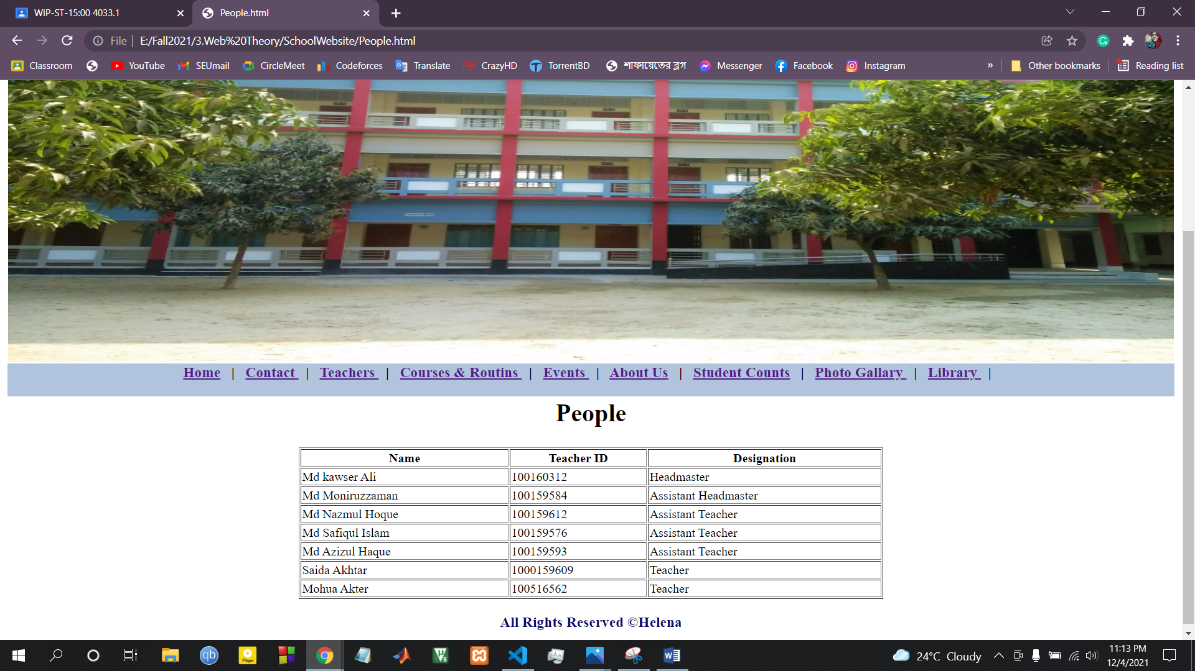

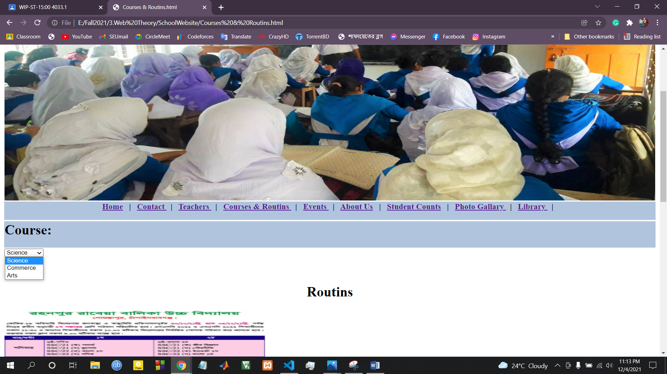

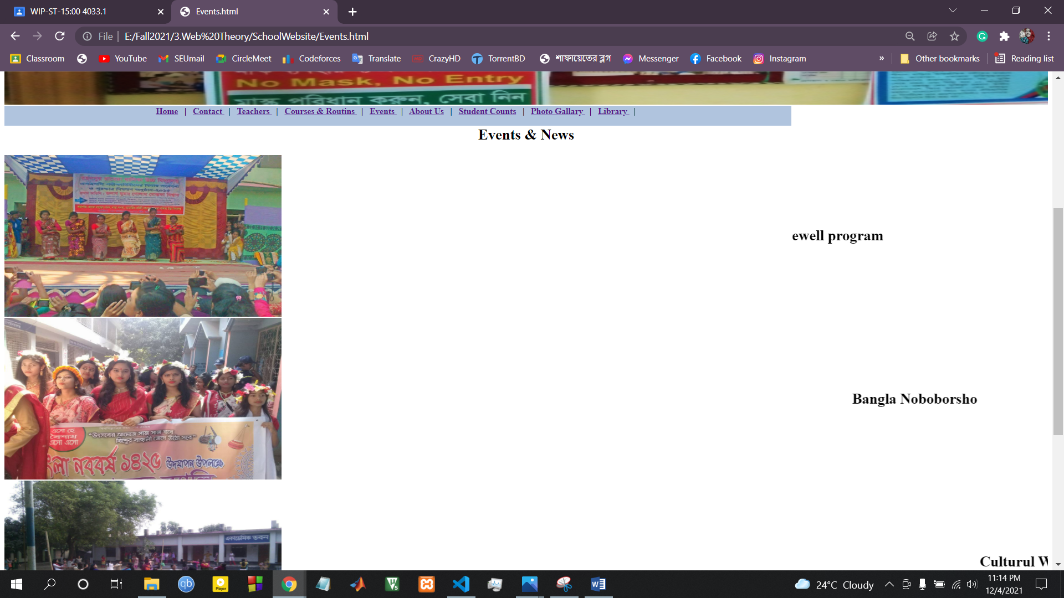

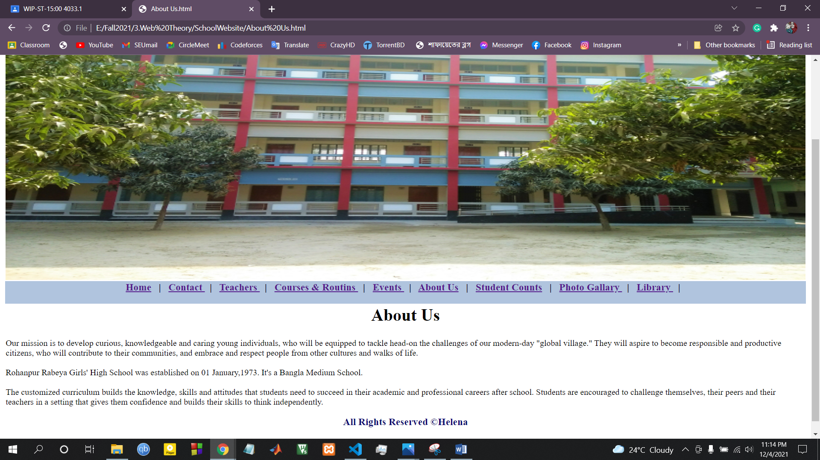

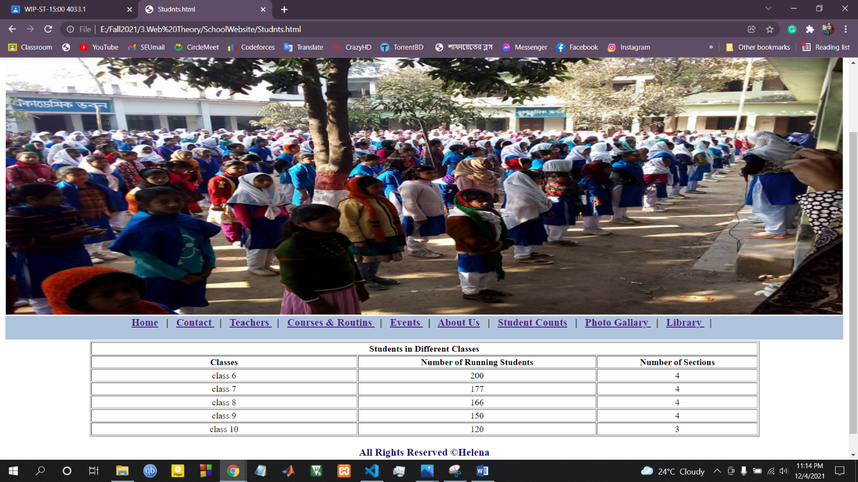

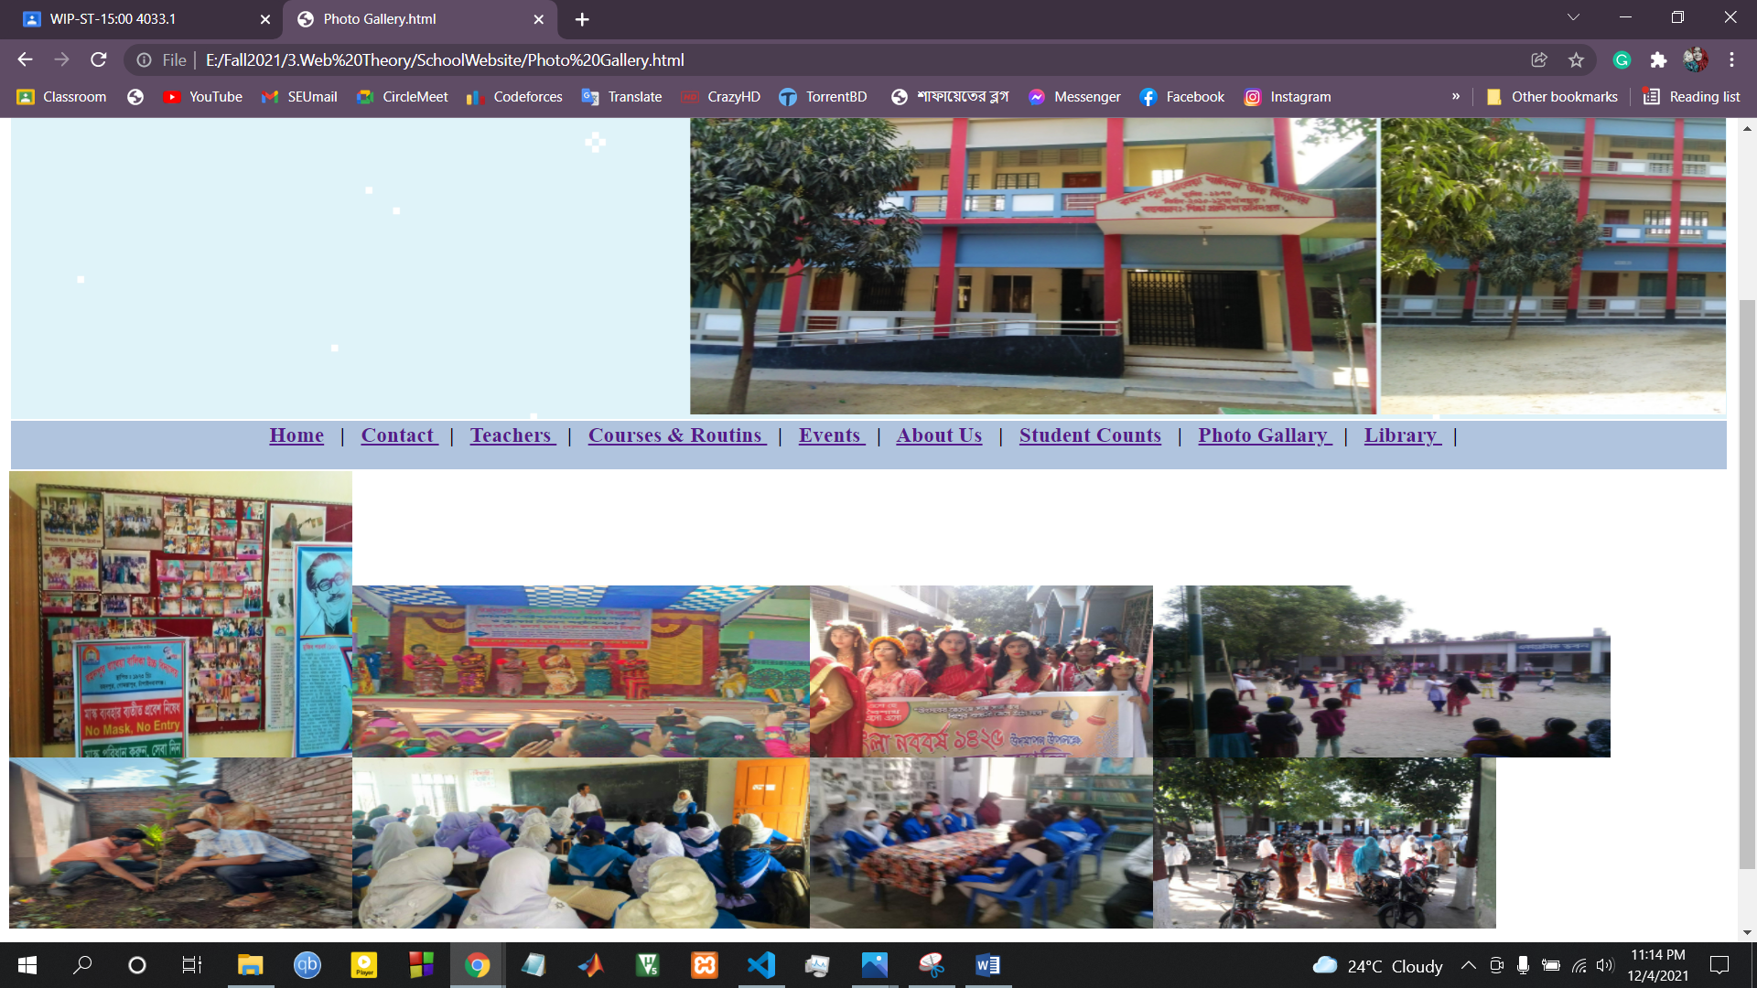

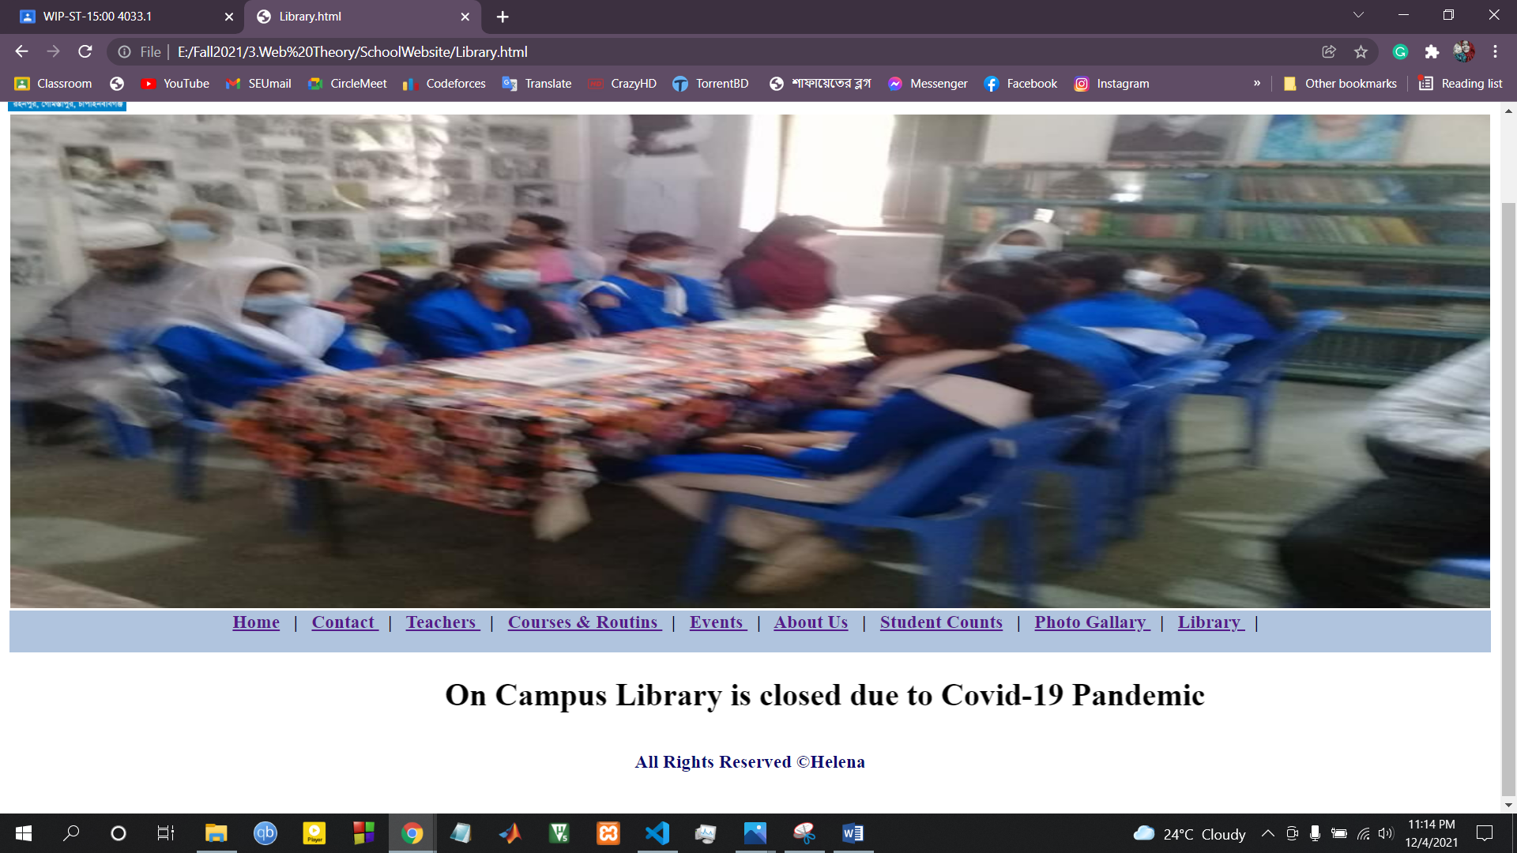

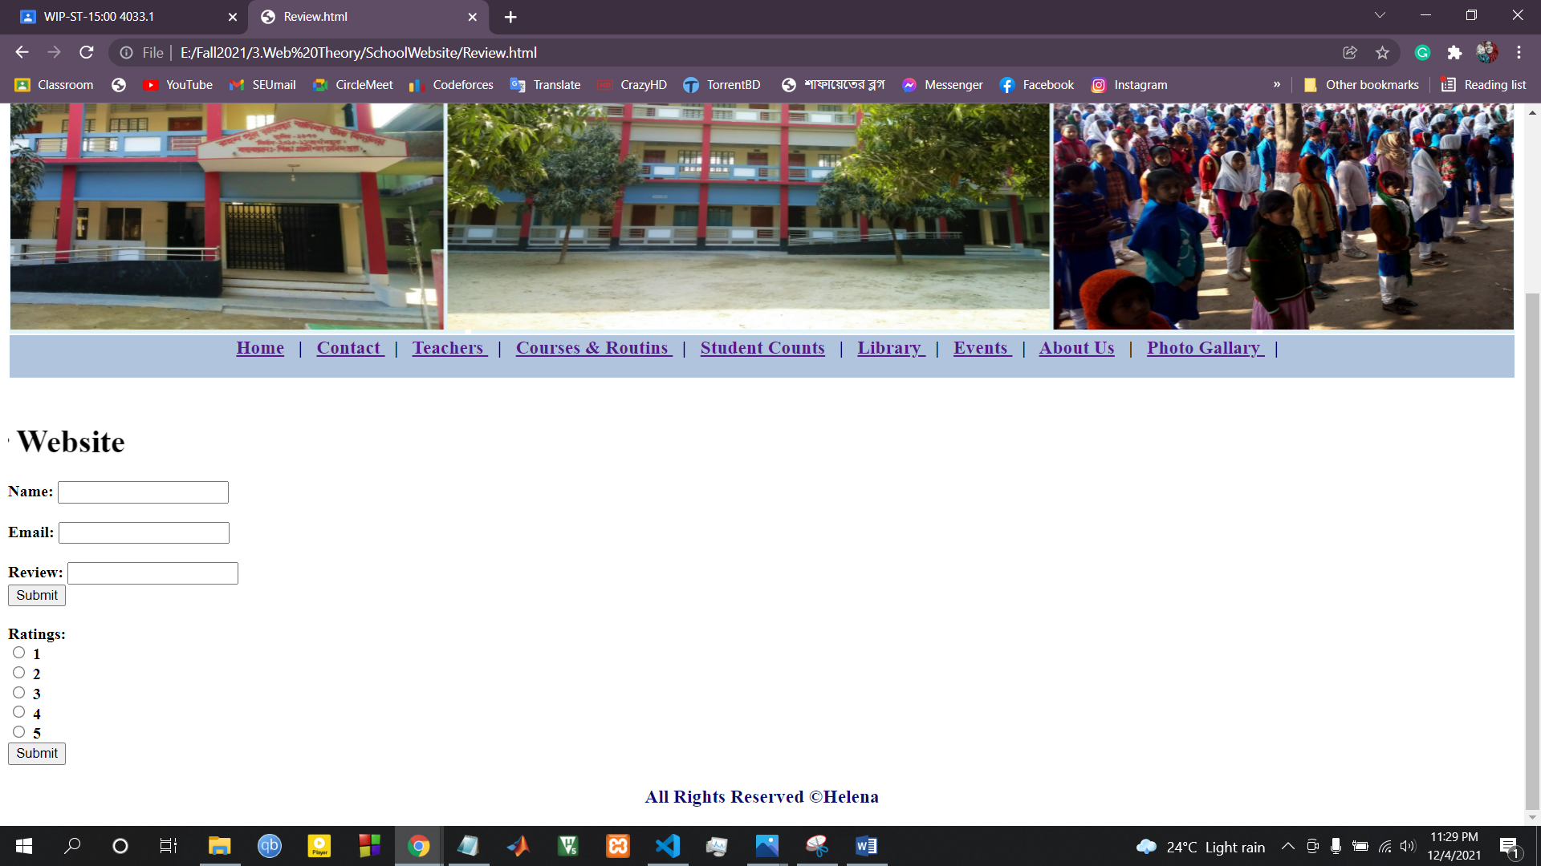

**Codes:**

**Home:**

<html>

<img src="logo.jpg" height="15%" width="8%" align= "left"/>

<h1 style="color: rgb(16, 11, 169);" align = "center">Rohanpur Rabeya Girls' High School</h1>

<table border="0" width="100%">

<tr width="100%" background ="background.gif">

<td>

<marquee behavior="scroll" direction="left" scrollamount="15">

<img src="scl1.jpg" width="600px" height="350px"/>

<img src="scl2.jpg" width="600px" height="350px" />

<img src="scl3.jpg" width="600px" height="350px" />

<img src="scl4.jpg" width="600px" height="350px" />

</marquee>

</td>

</tr>

<tr>

<td bgcolor="#B0C4DE">

<h3 align="center">

<a href="Home0.html"> Home</a> &nbsp | &nbsp

<a href="Contact.html"> Contact </a> &nbsp | &nbsp

<a href="People.html"> Teachers </a> &nbsp | &nbsp

<a href="Courses & Routins.html"> Courses & Routins </a> &nbsp | &nbsp

<a href="Studnts.html"> Student Counts</a> &nbsp | &nbsp

<a href="Library.html"> Library </a> &nbsp | &nbsp

<a href="Events.html"> Events </a> &nbsp | &nbsp

<a href="About Us.html"> About Us</a> &nbsp | &nbsp

<a href="Photo Gallery.html"> Photo Gallary </a> &nbsp | &nbsp

<a href="Registration.html"> Registration </a>

</h3>

</td>

</tr>

<tr>

<body>

<td height ="60"> <br>

<font size="4" align ="center"> <b> Rohanpur Rabeya Girls' High School </b> </font> is an academic institute located at

Rahamatpara, Rohanpur, Gomastapur, Chapai Nawabganj.

It's institute code (<b>EIIN </b>) is <b> 124352 </b>.

It was established on 01 January,1973.

It's co-education type is Girl's. The institute has following 3 disciplines:

<b> Business Studies </b>, <b> Humanities </b>, <b> Science </b>. It's <b> MPO </b> number is <b> 8502081301</b>

</b>. It has Day shift only.

</td>

</body>

</tr>

<tr>

<td> <br> <br>

<H3>

<center> <a href="Review.html"> Review Our Website </a> </center>

</H3>

</td>

</tr>

<tr> <br> <br>

<td colspan="2" height="70"> <h3 style="color: rgb(12, 11, 111);" align = "center"> All Rights Reserved &copy;Helena </h3> </td>

</tr>

</table>

</html>

**Contact:**

<html>

<img src="logo.jpg" height="15%" width="8%" align= "left"/>

<h1 style="color: rgb(16, 11, 169);" align = "center">Rohanpur Rabeya Girls' High School</h1>

<table border="0" width="100%">

<tr>

<td>

<img src="Scl1.jpg" height="500" width="100%">

</td>

</tr>

<tr>

<td bgcolor="#B0C4DE">

<h3 align="center">

<a href="Home0.html"> Home</a> &nbsp | &nbsp

<a href="Contact.html"> Contact </a> &nbsp | &nbsp

<a href="People.html"> Teachers </a> &nbsp | &nbsp

<a href="Courses & Routins.html"> Courses & Routins </a> &nbsp | &nbsp

<a href="Events.html"> Events </a> &nbsp | &nbsp

<a href="About Us.html"> About Us</a> &nbsp | &nbsp

<a href="Studnts.html"> Student Counts</a> &nbsp | &nbsp

<a href="Photo Gallery.html"> Photo Gallary </a> &nbsp | &nbsp

<a href="Library.html"> Library </a> &nbsp | &nbsp

</h3>

</td>

</tr>

<tr>

<td>

<h1 align= "center"> Contact </h1>

</td>

</tr>

<tr>

<body>

<td>

<b> Mobile:</b> 01729507790 <br>

<b> Email:</b> r.r.g.h.s124352@gmail.com <br>

<b> Adress:</b> Rahamatpara, Rohanpur, Gomastapur, Chapai Nawabganj.

</td>

</body>

</tr>

<tr>

<td height="70"> <h3 style="color: rgb(12, 11, 111);" align = "center"> All Rights Reserved &copy;Helena </h3> </td>

</tr>

</table>

</html>

**Teachers:**

<html>

<img src="logo.jpg" height="15%" width="8%" align= "left"/>

<h1 style="color: rgb(16, 11, 169);" align = "center">Rohanpur Rabeya Girls' High School</h1>

<table border="0" width="100%">

<tr>

<td>

<img src="Scl2.jpg" height="500" width="100%">

</td>

</tr>

<tr>

<td bgcolor="#B0C4DE">

<h3 align="center">

<a href="Home0.html"> Home</a> &nbsp | &nbsp

<a href="Contact.html"> Contact </a> &nbsp | &nbsp

<a href="People.html"> Teachers </a> &nbsp | &nbsp

<a href="Courses & Routins.html"> Courses & Routins </a> &nbsp | &nbsp

<a href="Events.html"> Events </a> &nbsp | &nbsp

<a href="About Us.html"> About Us</a> &nbsp | &nbsp

<a href="Studnts.html"> Student Counts</a> &nbsp | &nbsp

<a href="Photo Gallery.html"> Photo Gallary </a> &nbsp | &nbsp

<a href="Library.html"> Library </a> &nbsp | &nbsp

</h3>

</td>

</tr>

<tr>

<td bgcolor="">

<h1 align= "center"> People </h1>

</td>

</tr>

<tr>

<table border="1" width="50%" align="center">

<tr>

<th>

Name

</th>

<th>

Teacher ID

</th>

<th>

Designation

</th>

</tr>

<td>

Md kawser Ali

</td>

<td>

100160312

</td>

<td>

Headmaster

</td>

</tr>

<tr>

<td>

Md Moniruzzaman

</td>

<td>

100159584

</td>

<td>

Assistant Headmaster

</td>

</tr>

<tr>

<td> Md Nazmul Hoque</td>

<td> 100159612</td>

<td> Assistant Teacher </td>

</tr>

<tr>

<td> Md Safiqul Islam</td>

<td> 100159576</td>

<td> Assistant Teacher</td>

</tr>

<tr>

<td> Md Azizul Haque</td>

<td>100159593</td>

<td> Assistant Teacher</td>

</tr>

<tr>

<td> Saida Akhtar</td>

<td> 1000159609</td>

<td> Teacher</td>

</tr>

<tr>

<td> Mohua Akter</td>

<td> 100516562</td>

<td>Teacher</td>

</tr>

</table>

</tr>

<tr>

<td height="70"> <h3 style="color: rgb(12, 11, 111);" align = "center"> All Rights Reserved &copy;Helena </h3> </td>

</tr>

</table>

</html>

**Courses & Routine:**

<html>

<img src="logo.jpg" height="15%" width="8%" align="left" />

<h1 style="color: rgb(16, 11, 169);" align="center">Rohanpur Rabeya Girls' High School</h1>

<table border="0" width="100%">

<tr>

<td>

<img src="Scl4.jpg" height="500" width="100%">

</td>

</tr>

<tr>

<td bgcolor="#B0C4DE">

<h3 align="center">

<a href="Home0.html"> Home</a> &nbsp | &nbsp

<a href="Contact.html"> Contact </a> &nbsp | &nbsp

<a href="People.html"> Teachers </a> &nbsp | &nbsp

<a href="Courses & Routins.html"> Courses & Routins </a> &nbsp | &nbsp

<a href="Events.html"> Events </a> &nbsp | &nbsp

<a href="About Us.html"> About Us</a> &nbsp | &nbsp

<a href="Studnts.html"> Student Counts</a> &nbsp | &nbsp

<a href="Photo Gallery.html"> Photo Gallary </a> &nbsp | &nbsp

<a href="Library.html"> Library </a> &nbsp | &nbsp

</h3>

</td>

</tr>

</table>

<table width="100%">

<tr>

<td bgcolor="#B0C4DE">

<h1>Course:</h1>

</td>

</tr>

<tr>

<td>

<select name="Course" id="course">

<h3>

<option value="Science">Science</option>

<option value="Commerce">Commerce</option>

<option value="Arts">Arts</option>

</select> </h3>

</td>

</tr>

<tr>

<td> <br><br>

<h1 align="center">Routins</h1>

</td>

</tr>

<tr>

<td>

<img src="Routine 1.jpg" width="600px" height="350px" />

</td>

</tr>

<tr>

<td>

<img src="Routine 2.jpg" width="600px" height="350px"/>

</td>

</tr>

<tr>

<td>

<img src="Routine 3.jpg" width="600px" height="350px" />

</td>

</tr>

</table>

</html>

**Events:**

<html>

<img src="logo.jpg" height="15%" width="8%" align= "left"/>

<h1 style="color: rgb(16, 11, 169);" align = "center">Rohanpur Rabeya Girls' High School</h1>

<table border="0" width="100%">

<tr>

<td colspan="2">

<img src="Event 1.jpg" height="500" width="100%">

</td>

</tr>

<tr>

<td bgcolor="#B0C4DE">

<h3 align="center">

<a href="Home0.html"> Home</a> &nbsp | &nbsp

<a href="Contact.html"> Contact </a> &nbsp | &nbsp

<a href="People.html"> Teachers </a> &nbsp | &nbsp

<a href="Courses & Routins.html"> Courses & Routins </a> &nbsp | &nbsp

<a href="Events.html"> Events </a> &nbsp | &nbsp

<a href="About Us.html"> About Us</a> &nbsp | &nbsp

<a href="Studnts.html"> Student Counts</a> &nbsp | &nbsp

<a href="Photo Gallery.html"> Photo Gallary </a> &nbsp | &nbsp

<a href="Library.html"> Library </a> &nbsp | &nbsp

</h3>

</td>

</tr>

<tr>

<td colspan="2">

<h1 align= "center"> Events & News </h1>

</td>

</tr>

<tr>

<td>

<img src="Event 2.jpg" width="600px" height="350px"/>

</td>

<td>

<marquee behavior="scroll" direction="left" scrollamount="15">

<h1>Farewell program</h1>

</marquee>

</td>

</tr>

<tr>

<td>

<img src="Event 3.jpg" width="600px" height="350px"/>

</td>

<td>

<marquee behavior="scroll" direction="left" scrollamount="15">

<h1> Bangla Noboborsho </h1>

</marquee>

</td>

</tr>

<tr>

<td>

<img src="Event 4.jpg" width="600px" height="350px"/>

</td>

<td>

<marquee behavior="scroll" direction="left" scrollamount="15">

<h1> Culturul Week</h1>

</marquee>

</td>

</tr>

<tr>

<td>

<img src="Event 5.jpg" width="600px" height="350px"/>

</td>

<td>

<marquee behavior="scroll" direction="left" scrollamount="15">

<h1> Tree Plantation program</h1>

</marquee>

</td>

</tr>

<tr>

<td height="70"> <h3 style="color: rgb(12, 11, 111);" align = "center"> All Rights Reserved &copy;Helena </h3> </td>

</tr>

</table>

</html>

**About Us:**

<html>

<img src="logo.jpg" height="15%" width="8%" align= "left"/>

<h1 style="color: rgb(16, 11, 169);" align = "center">Rohanpur Rabeya Girls' High School</h1>

<table border="0" width="100%">

<tr>

<td>

<img src="Scl2.jpg" height="500" width="100%">

</td>

</tr>

<tr>

<td bgcolor="#B0C4DE">

<h3 align="center">

<a href="Home0.html"> Home</a> &nbsp | &nbsp

<a href="Contact.html"> Contact </a> &nbsp | &nbsp

<a href="People.html"> Teachers </a> &nbsp | &nbsp

<a href="Courses & Routins.html"> Courses & Routins </a> &nbsp | &nbsp

<a href="Events.html"> Events </a> &nbsp | &nbsp

<a href="About Us.html"> About Us</a> &nbsp | &nbsp

<a href="Studnts.html"> Student Counts</a> &nbsp | &nbsp

<a href="Photo Gallery.html"> Photo Gallary </a> &nbsp | &nbsp

<a href="Library.html"> Library </a> &nbsp | &nbsp

</h3>

</td>

</tr>

<tr>

<td>

<h1 align= "center"> About Us </h1>

</td>

</tr>

<tr>

<td>

Our mission is to develop curious, knowledgeable and caring young individuals, who will be equipped to tackle head-on the challenges of our modern-day "global village." They will aspire to become responsible and productive citizens, who will contribute to their communities, and embrace and respect people from other cultures and walks of life.

<br> <br>

Rohanpur Rabeya Girls' High School was established on 01 January,1973.

It's a Bangla Medium School.

<br> <br>

The customized curriculum builds the knowledge, skills and attitudes that students need to succeed in their academic and professional careers after school. Students are encouraged to challenge themselves, their peers and their teachers in a setting that gives them confidence and builds their skills to think independently.

</td>

</tr>

<tr>

<td height="70"> <h3 style="color: rgb(12, 11, 111);" align = "center"> All Rights Reserved &copy;Helena </h3> </td>

</tr>

</table>

</html>

**Student Counts:**

<html>

<img src="logo.jpg" height="15%" width="8%" align= "left"/>

<h1 style="color: rgb(16, 11, 169);" align = "center">Rohanpur Rabeya Girls' High School</h1>

<table border="0" width="100%">

<tr>

<td>

<img src="Scl3.jpg" height="500" width="100%">

</td>

</tr>

<tr>

<td bgcolor="#B0C4DE">

<h3 align="center">

<a href="Home0.html"> Home</a> &nbsp | &nbsp

<a href="Contact.html"> Contact </a> &nbsp | &nbsp

<a href="People.html"> Teachers </a> &nbsp | &nbsp

<a href="Courses & Routins.html"> Courses & Routins </a> &nbsp | &nbsp

<a href="Events.html"> Events </a> &nbsp | &nbsp

<a href="About Us.html"> About Us</a> &nbsp | &nbsp

<a href="Studnts.html"> Student Counts</a> &nbsp | &nbsp

<a href="Photo Gallery.html"> Photo Gallary </a> &nbsp | &nbsp

<a href="Library.html"> Library </a> &nbsp | &nbsp

</h3>

</td>

</tr>

<tr>

<td>

<table border="1" align="center" height="100%" width="80%">

<tr align="center">

<th colspan="3">Students in Different Classes</th>

</tr>

<tr align="center">

<th width=" 40%">Classes</th>

<th>Number of Running Students</th>

<th>Number of Sections</th>

</tr>

<tr align="center">

<td>class 6</td>

<td>200</td>

<td>4</td>

</tr>

<tr align="center">

<td>class 7</td>

<td>177</td>

<td>4</td>

</tr>

<tr align="center">

<td>class 8</td>

<td>166</td>

<td>4</td>

</tr>

<tr align="center">

<td>class 9</td>

<td>150</td>

<td>4</td>

</tr>

<tr align="center">

<td>class 10</td>

<td>120</td>

<td>3</td>

</tr>

</table>

</td>

</tr>

<tr>

<td colspan="2" height="70"> <h3 style="color: rgb(12, 11, 111);" align = "center"> All Rights Reserved &copy;Helena </h3> </td>

</tr>

</table>

</html>

**Photo Gallery:**

<html>

<img src="logo.jpg" height="15%" width="8%" align= "left"/>

<h1 style="color: rgb(16, 11, 169);" align = "center">Rohanpur Rabeya Girls' High School</h1>

<h3 align= "right"> <a href="Register.html"> Register </a> </h3>

<table border="0" width="100%">

<tr width="100%" background ="background.gif">

<td>

<marquee behavior="scroll" direction="left" scrollamount="15">

<img src="scl1.jpg" width="600px" height="350px"/>

<img src="scl2.jpg" width="600px" height="350px" />

<img src="scl3.jpg" width="600px" height="350px" />

<img src="scl4.jpg" width="600px" height="350px" />

</marquee>

</td>

</tr>

<tr>

<td bgcolor="#B0C4DE">

<h3 align="center">

<a href="Home0.html"> Home</a> &nbsp | &nbsp

<a href="Contact.html"> Contact </a> &nbsp | &nbsp

<a href="People.html"> Teachers </a> &nbsp | &nbsp

<a href="Courses & Routins.html"> Courses & Routins </a> &nbsp | &nbsp

<a href="Events.html"> Events </a> &nbsp | &nbsp

<a href="About Us.html"> About Us</a> &nbsp | &nbsp

<a href="Studnts.html"> Student Counts</a> &nbsp | &nbsp

<a href="Photo Gallery.html"> Photo Gallary </a> &nbsp | &nbsp

<a href="Library.html"> Library </a> &nbsp | &nbsp

</h3>

</td>

</tr>

<table>

<body>

<img src="Event 1.jpg" width="300px" height="250px"/>

<img src="Event 2.jpg" width="400px" height="150px"/>

<img src="Event 3.jpg" width="300px" height="150px"/>

<img src="Event 4.jpg"width="400px" height="150px"/>

<img src="Event 5.jpg"width="300px" height="150px"/>

<img src="Scl4.jpg" width="400px" height="150px"/>

<img src="Lib1.jpg" width="300px" height="150px"/>

<img src="pic1.jpg" width="300px" height="150px"/>

</body>

</table>

</table>

<table width="100%">

<tr>

<td colspan="2" height="70"> <h3 style="color: rgb(12, 11, 111);" align = "center"> All Rights Reserved &copy;Helena </h3> </td>

</tr>

</table>

</html>

**Library:**

<html>

<img src="logo.jpg" height="15%" width="8%" align="left" />

<h1 style="color: rgb(16, 11, 169);" align="center">Rohanpur Rabeya Girls' High School</h1>

<table border="0" width="100%">

<tr>

<td>

<img src="lib1.jpg" height="500" width="100%">

</td>

</tr>

<tr>

<td bgcolor="#B0C4DE">

<h3 align="center">

<a href="Home0.html"> Home</a> &nbsp | &nbsp

<a href="Contact.html"> Contact </a> &nbsp | &nbsp

<a href="People.html"> Teachers </a> &nbsp | &nbsp

<a href="Courses & Routins.html"> Courses & Routins </a> &nbsp | &nbsp

<a href="Events.html"> Events </a> &nbsp | &nbsp

<a href="About Us.html"> About Us</a> &nbsp | &nbsp

<a href="Studnts.html"> Student Counts</a> &nbsp | &nbsp

<a href="Photo Gallery.html"> Photo Gallary </a> &nbsp | &nbsp

<a href="Library.html"> Library </a> &nbsp | &nbsp

</h3>

</td>

</tr>

<tr>

<td>

<marquee behavior="scroll" direction="left" scrollamount="15">

<h1>On Campus Library is closed due to Covid-19 Pandemic</h1>

</marquee>

</td>

</tr>

<tr>

<td colspan="2" height="70">

<h3 style="color: rgb(12, 11, 111);" align="center"> All Rights Reserved &copy;Helena </h3>

</td>

</tr>

</table>

</html>

**Review:**

<html>

<html>

<img src="logo.jpg" height="15%" width="8%" align= "left"/>

<h1 style="color: rgb(16, 11, 169);" align = "center">Rohanpur Rabeya Girls' High School</h1>

<table border="0" width="100%">

<tr width="100%" background ="background.gif">

<td>

<marquee behavior="scroll" direction="left" scrollamount="15">

<img src="scl1.jpg" width="600px" height="350px"/>

<img src="scl2.jpg" width="600px" height="350px" />

<img src="scl3.jpg" width="600px" height="350px" />

<img src="scl4.jpg" width="600px" height="350px" />

</marquee>

</td>

</tr>

<tr>

<td bgcolor="#B0C4DE">

<h3 align="center">

<a href="Home0.html"> Home</a> &nbsp | &nbsp

<a href="Contact.html"> Contact </a> &nbsp | &nbsp

<a href="People.html"> Teachers </a> &nbsp | &nbsp

<a href="Courses & Routins.html"> Courses & Routins </a> &nbsp | &nbsp

<a href="Studnts.html"> Student Counts</a> &nbsp | &nbsp

<a href="Library.html"> Library </a> &nbsp | &nbsp

<a href="Events.html"> Events </a> &nbsp | &nbsp

<a href="About Us.html"> About Us</a> &nbsp | &nbsp

<a href="Photo Gallery.html"> Photo Gallary </a> &nbsp | &nbsp

</h3>

</td>

</tr>

</table>

<body><h4>

<marquee behavior="scroll" direction="left" scrollamount="15">

<h1>Review Our Website</h1>

</marquee>

<form action="/action_page.php">

Name: <input type="text" name="name">

<br> <br>

Email: <input type="text" mail="email">

<br><br>

Review: <input type="text" name="age">

<br>

<input type="submit" value="Submit"> <br>

<br>Ratings: <br>

<input type="radio" name="Ratings" value="1"> 1<br>

<input type="radio" name="Ratings" value="2"> 2<br>

<input type="radio" name="Ratings" value="3"> 3<br>

<input type="radio" name="Ratings" value="4"> 4<br>

<input type="radio" name="Ratings" value="5"> 5<br>

<input type="submit" value="Submit">

</form>

</body>

</h4>

<h3 style="color: rgb(12, 11, 111);" align = "center"> All Rights Reserved &copy;Helena </h3>

</html>